IT/Computer Science Job activities and tasks

Classify these tasks according to their project phase 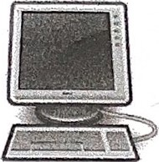

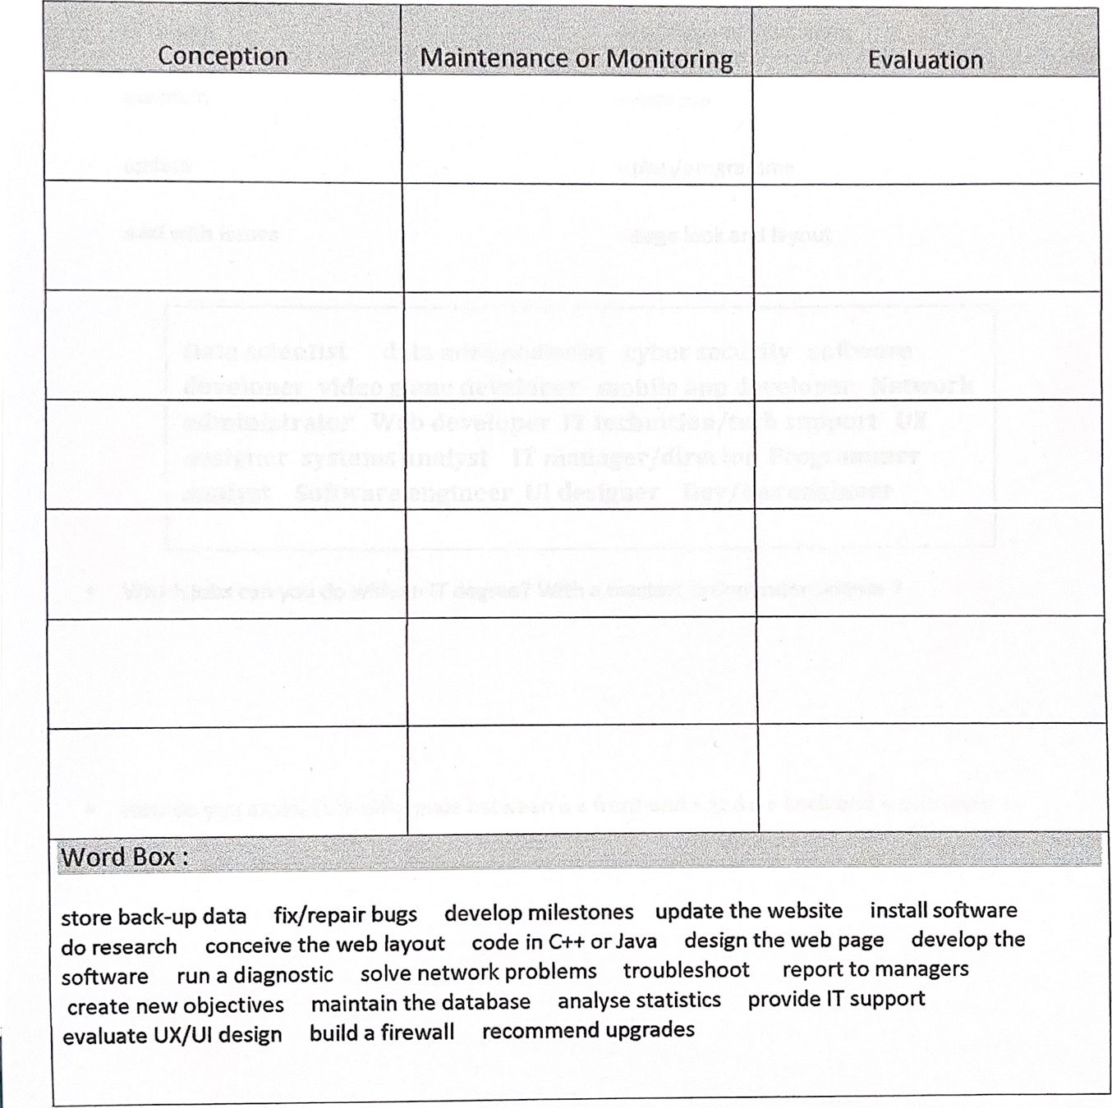

Analyse statistics

Provide IT support

Recommend upgrades

Troubleshoot

Run a diagnostic

Do research

Develop milestones

Build a firewall

Maintain the database

Create new objectives

Solve network problems

Develop the software

Evaluate UX/UI design

Install software

Update the website

Fix/repair bugs

Store back-up data

Design the web page

Code in C++ or Java

Conceive the web layout

Exercice 2: find a synonym

responsible for developing



 schedule

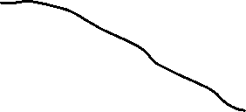

* Help desk



* UI design
* maintain
* Update
* Deal with issues
* Monitor
* IT support
* Deal with problems
* In charge of developing
* improve
* Plan/programme
* Page look and layout

Data scientist data administrator cyber security software developer video game developer mobile app developer Network administrator Web developer IT technician/tech support UX designer systems analyst IT manager/director Programmer analyst Software engineer UI designer Dev/op’s engineer

* Which jobs can you do with an IT degree? With a master’s in computer science? 

With an IT degree: IT manager/director, Network administrator, IT technician/tech support,

 How do you explain the difference between a “front-end” and a “back-end” developer?

The difference between a « front-end” and a “back-end” developer is. The “front-end” developer creates part of website who all people can be saw. As invert, the “back-end” developer, develop the system who nobody can be see, it’s the functionalities of the website.

The “front-end” developer is the part of all people can be seen. The “back-end” is all of you can be not see.

What's the difference between a UX and a UI designer?

The UX, is the User Experience. Is the back of the design and the UI is the front of the designer.

The UI, is a designer who design all the user see on a page or app.



If a software developer builds the software, what does a software engineer do?

The software engineer do have more competence in maths and others ..

Which job necessitates both strong math skills and the ability to program and process data in R, Python, etc...

Data scientist

What's the difference between a programmer analyst and a systems analyst ?

System analyst does more problem research and problem solutions, and for programmer analyst directly with a business or client.

Choose 3 jobs from the list that are more involved with maintenance and administration.

Data administration / Network administration / System analyst / IT Support

In which jobs do you need to have both an overall understanding of programming and strong project management skills ?

Programmer analyst / IT Director

Which jobs are more involved with the developing, building and conceiving of products ?

All jobs of developer.